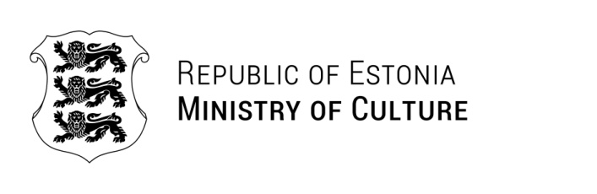

Glenn Micallef | Yours: 26.03.2025 | No 10.1-13/266-1
Cabinet of Commissioner Glenn MICALLEF
EAC-UA-HERITAGE@ec.europa.eu  Stephanie.BONNICI@ec.europa.eu | Ours: {regDateTime} | No {regNumber}

Dear Commissioner,

Thank you very much for your letter and for your important call to coordinate the contribution of EU Member States to the protection, preservation, and reconstruction of Ukraine’s cultural heritage. We greatly appreciate this initiative, which aligns closely with the priorities of the Estonian Ministry of Culture.

In addition to specific and already planned initiatives – including a Ukrainian art festival, a large exhibition dedicated to the defenders of Azovstal, and artist residencies – Estonia is committed to contributing through knowledge sharing, capacity building, and expert cooperation.

As one of the most digitally advanced countries in Europe, Estonia has extensive experience in areas such as heritage digitisation, digital preservation, architectural competitions, and institutional capacity building. We are ready to share this expertise with our Ukrainian colleagues in formats that best suit their needs – be it through online trainings, study visits, or expert missions.

We believe that this type of collaboration can be even more impactful when carried out jointly with other Member States as part of wider EU initiatives. Estonia has already gained valuable experience from such multilateral efforts and looks forward to continuing this work under the Team Europe framework.

Estonia has also proposed an EU-level analysis of the possibilities for cross border preservation of the digital cultural heritage of Member States. In light of the current geopolitical context and the war in Ukraine, it is crucial to include Ukraine in these discussions and processes. We believe that Ukraine’s experience in preserving cultural heritage under threat can provide important lessons for all of us.

We thank you once again for this initiative and remain ready to contribute actively.

Yours sincerely,

Heidy Purga
Minister of Culture of Estonia

Additional recipients:
Ministry of Foreign Affairs

Anneli Vilu +372 6282235
Anneli.Vilu@kul.ee

